CSCE 606 Iteration 2

Customer meeting date to demo this iteration:

We meet every Thursday morning at 11:00

User stories implemented in this iteration:

Feature: Add an authentication and session

As a user to the website

So that I need to use the valid email address and name to register

I want to use the valid email to login and keep the login status

Heroku Link:

<https://fierce-meadow-77560.herokuapp.com>

<https://git.heroku.com/cryptic-bastion-14375.git>

Github

<https://github.com/marshalma/DiseaseDatasetCuration>

Pivottracker:

https://www.pivotaltracker.com/n/projects/1565533

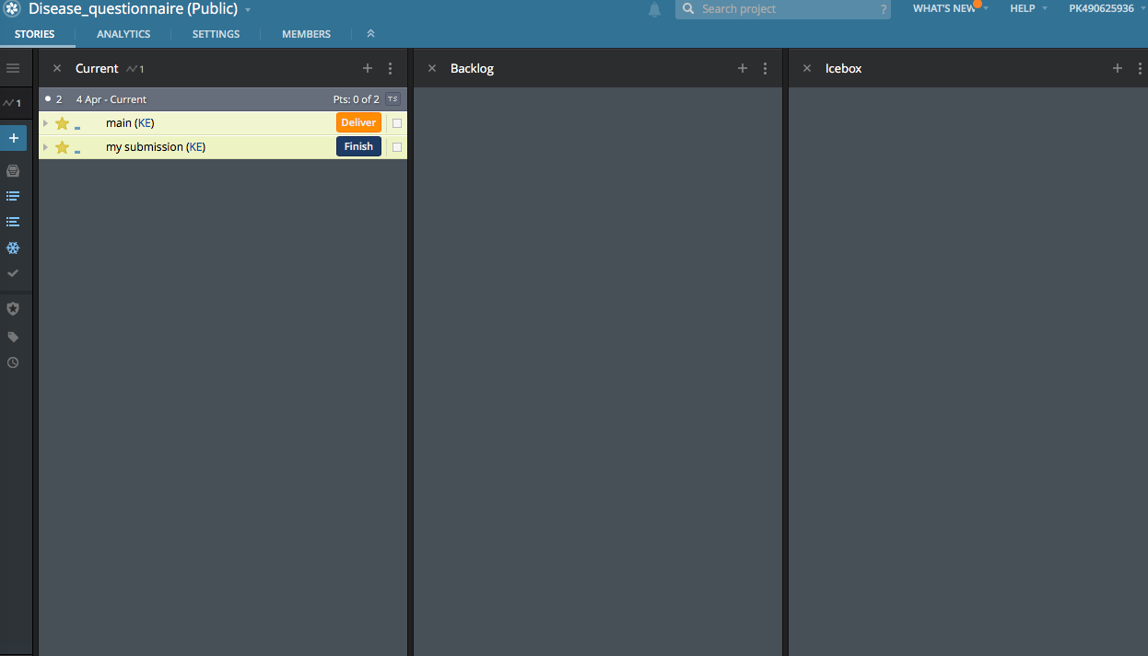

BDD

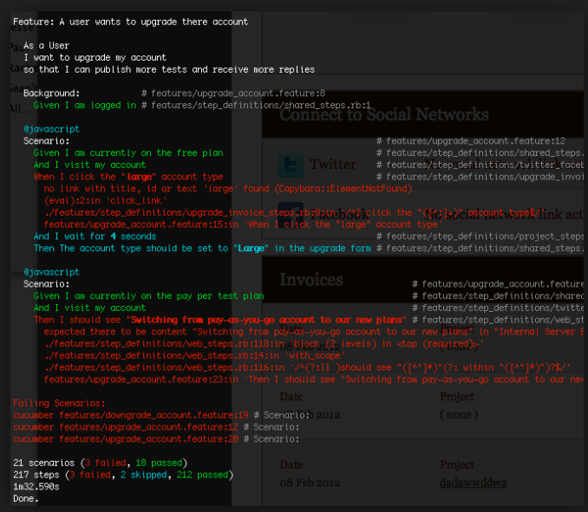

TDD

